A. Select one of the provided scenarios to complete the following:
1. Describe a business problem that can be solved with a database solution and is in alignment with the chosen scenario.
We want to know which gender has more allergies, medications, and medical conditions.
2. Propose a data structure to solve the identified business problem.
- The chosen data structure is a relational database schema with tables that include array-type columns to handle multiple entries per patient. The data is relational aka each patient may have multiple allergies, medications, and conditions. Arrays or lists embedded inside relational tables (like PostgreSQL arrays or JSON fields) allow flexible storage of multiple related data points without excessive table joins or complex normalization. A relational model preserves data integrity via primary keys (unique patient IDs) and foreign keys (linking medical records to patients). SQL queries provide powerful ways to filter, group, and aggregate data from these arrays efficiently.
3. Justify why a database solution will solve the identified business problem.
Using a relational database management system ensures data consistency with primary and foreign keys. Enables complex queries with joins and filters. Supports scalable data storage capable of handling thousands or millions of patient records. Provides security features to protect sensitive medical information.
4. Explain how the business data will be used within the database solution.
This business data will be used by know and comprehending what the data structure is, and we will format it into a table (array) with columns that contain data of the same type. Each row will be unique because it belongs to individual patients. Data will be structured so that: Patients table holds basic demographic info (patient_id, name, DOB, gender). Medical_Records table stores arrays of conditions, medications, allergies, and other data per patient. When queries run: The system joins these tables on patient_id. Filters on conditions or medications arrays. Groups results by gender to count occurrences or calculate proportions. Supporting Preventive Care Strategies: By identifying the most common conditions or medications associated with each gender, providers can tailor education and outreach programs. If a certain heart condition is prevalent among males aged 40–60, a targeted screening campaign can be launched for early intervention. Insights into which gender is prescribed more medications can help the pharmacy department optimize medication inventory. If one gender consistently requires more asthma medication, clinics can ensure stock is maintained accordingly, reducing risk of shortages. Analysis may reveal disparities in the number or types of conditions diagnosed by gender. If women are underdiagnosed for certain conditions, the organization can investigate and retrain staff on diagnostic protocols.
B. Create a logical data model for storing data in the database solution.
Patients
patient_id (PK)
name
date_of_birth
gender
| 1:M
Medical_Records
record_id (PK)
patient_id (FK)
medical_conditions
medications
allergies
last_appointment_date
tracker

C. Describe the database objects and storage, identifying the file attributes within the database solution.
1. Database Objects
Tables:
patients → Stores patient details (patient_id as PK, name, date_of_birth, gender).
medical_records → Stores medical history (record_id as PK, patient_id as FK, medical_conditions, medications, allergies, last_appointment_date).
Indexes:
Index on patient_id in medical_records to optimize retrieval.
Index on medical_conditions and medications for faster searches.
2. Storage Mechanism in PostgreSQL
Data Files:
Stored in PostgreSQL tablespaces under pg_data.
Data Types:
VARCHAR, TEXT → Patient names, conditions, medications.
DATE → Birthdates and appointment records.
BOOLEAN → Allergy indicators.
Object | Attributes | Data Types | Description
patients | patient_id (PK) | INTEGER (Primary Key) | Unique identifier for each patient
 | name | VARCHAR(100) | Patient’s full name
 | date_of_birth | DATE | Patient birth date
 | gender | VARCHAR(10) | Patient gender (e.g., 'Male', 'Female')
medical_records | record_id (PK) | INTEGER (Primary Key) | Unique medical record ID
 | patient_id (FK) | INTEGER (Foreign Key) | Links to patients.patient_id
 | medical_conditions | TEXT[] (Array) | List of medical conditions
 | medications | TEXT[] (Array) | List of medications
 | allergies | TEXT[] (Array) | List of allergies
 | last_appointment_date | DATE | Date of last appointment
 | tracker | TEXT | Additional notes or status information

D. Discuss how the proposed database design addresses scalability concerns, including strategies that align with the chosen scenario.
Minimizes redundant data by separating patients and medical records, allowing efficient updates. Primary key and GIN indexes optimize query speed, especially for large datasets with many records. Additional CPU, RAM, and SSDs improve throughput as dataset size grows. Data can be partitioned by date or patient demographics to distribute load. Efficiently manages multiple user queries simultaneously, reducing latency. PostgreSQL’s planner chooses optimal execution plans for queries. Older data can be archived to maintain performance on active records.
E. Outline the privacy and security measures that should be implemented in the proposed database design.
Authentication and Authorization: Role-based access control ensures only authorized users can view or modify patient data. Use SSL/TLS to encrypt connections between clients and database server. Encrypt sensitive columns or full disk encryption on storage. Record all access and modification events, including failed login attempts, for compliance and intrusion detection. Mask sensitive information when used in reports or analytics to protect privacy. Automated backup schedules and secure storage to recover data in case of failure. Lastly we should monitor for abnormal access patterns and respond automatically.
F. Implement the proposed database design in the WGU Virtual Lab environment by completing the following:
1. Write script to create a database instance named “D597 Task 1” using the appropriate query language, based on the logical data model in part B. Provide a screenshot showing the script and the database instance in the platform.
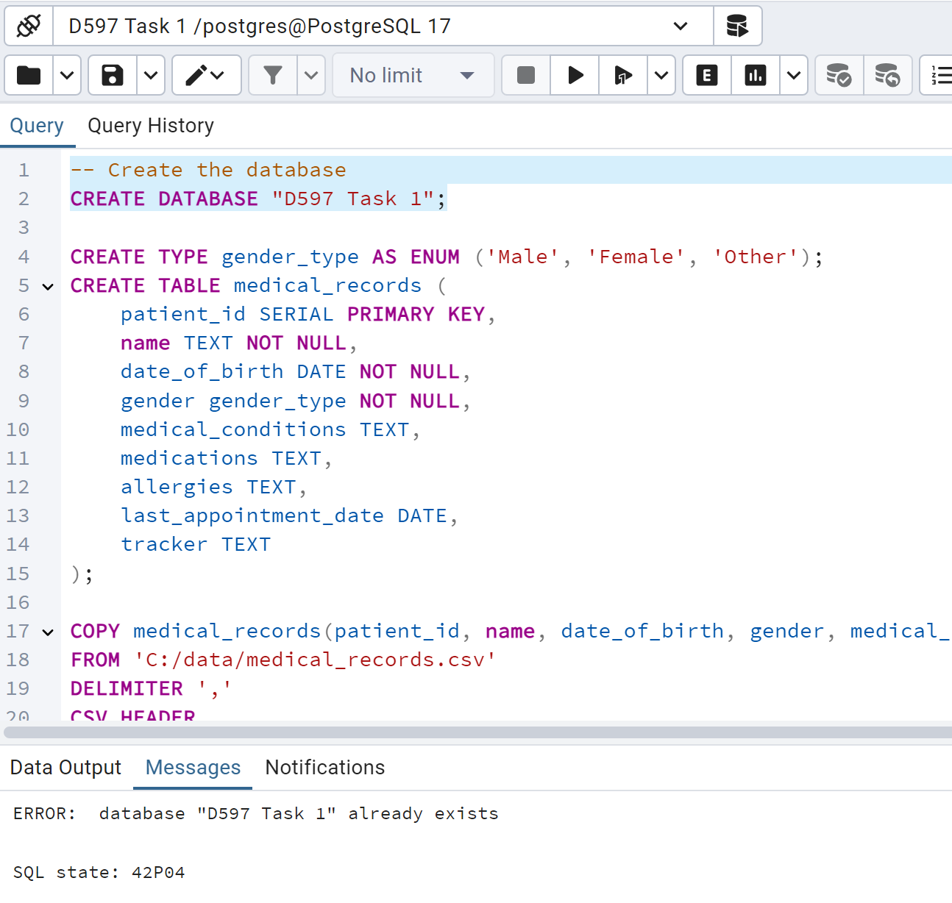
2. Write script to import the data records from the chosen scenario CSV files into the database instance. Provide a screenshot showing the script and the data correctly inserted or mapped into the database.
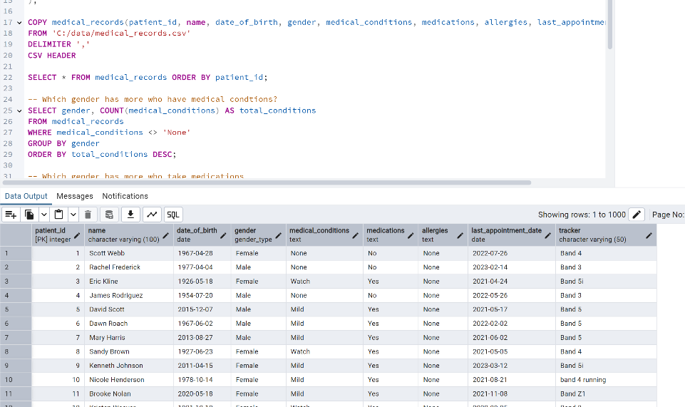
3. Write script for three queries to retrieve specific information from the database that will help to solve the identified business problem. Provide a screenshot showing the script for each query and each query successfully executed.
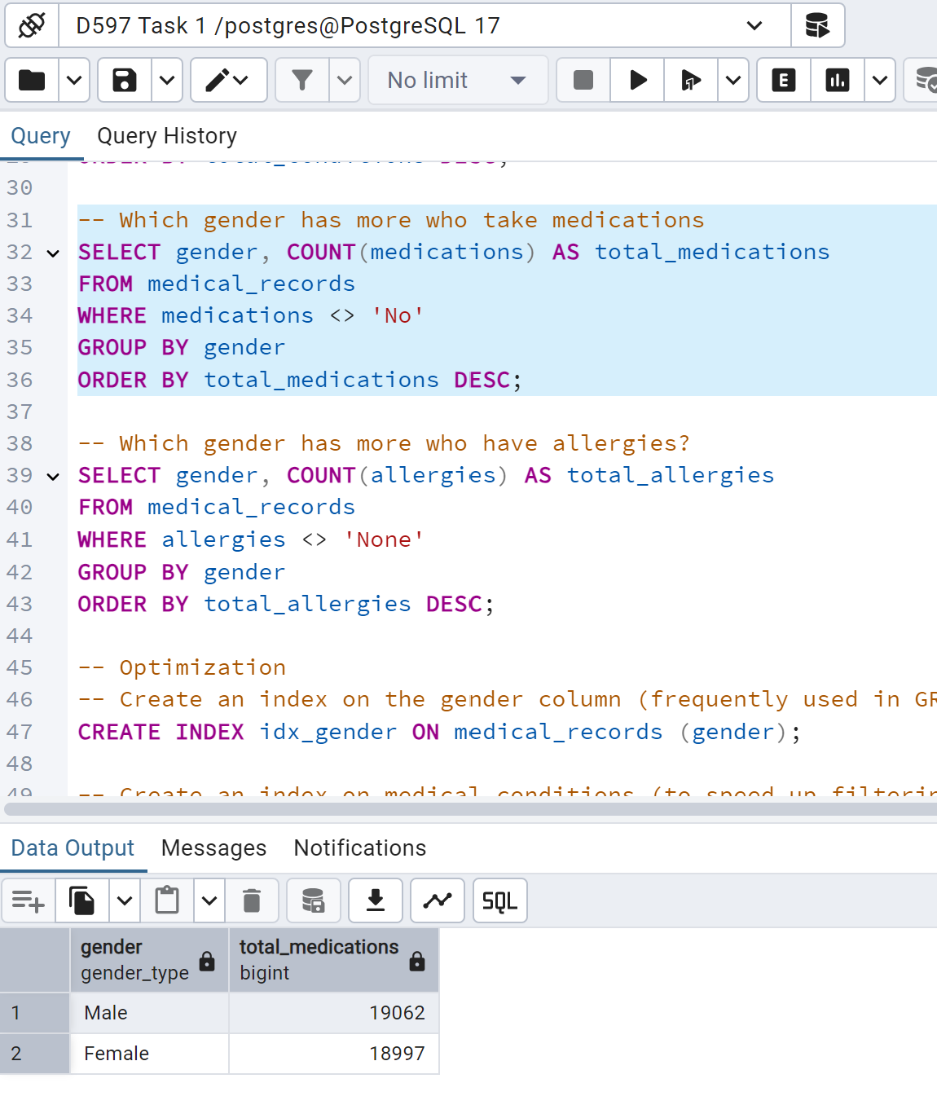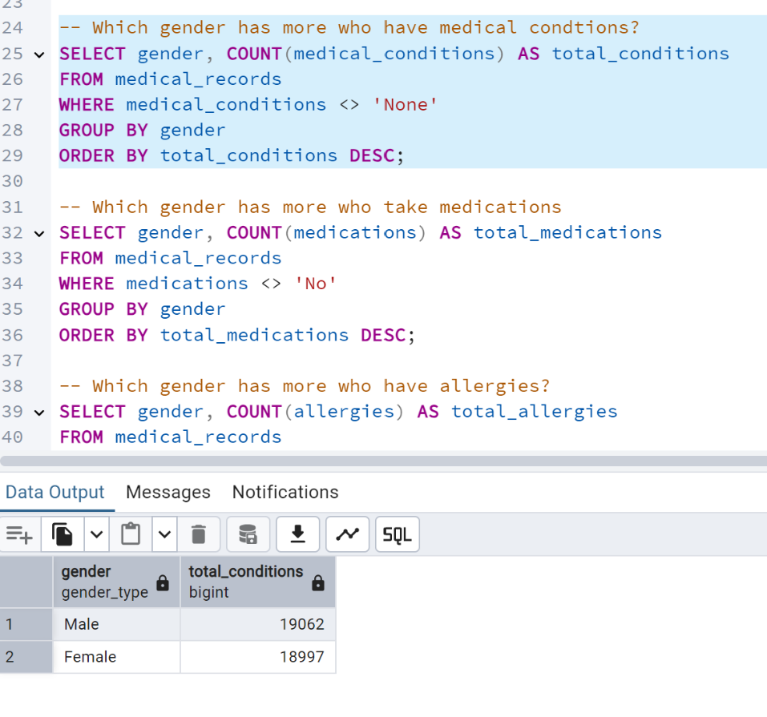
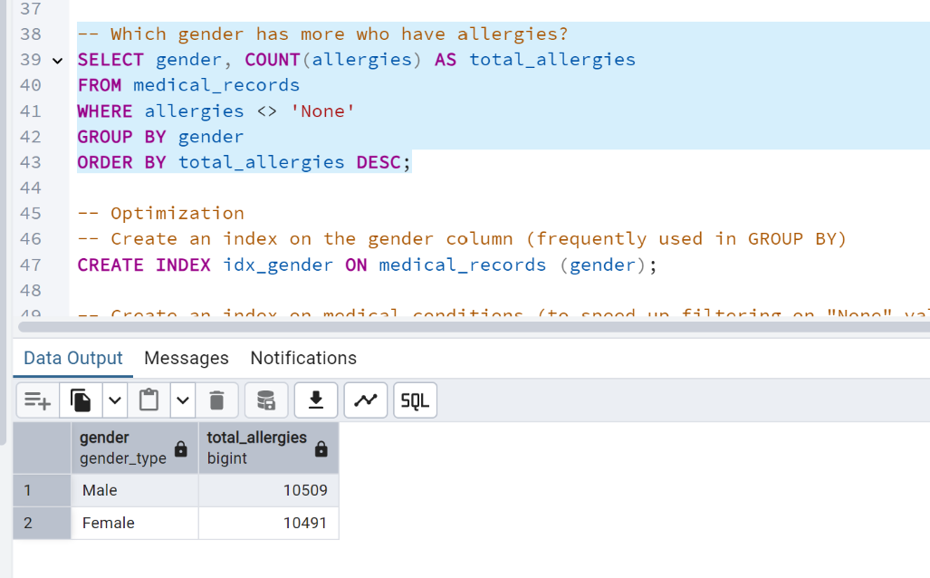
4. Apply optimization techniques to improve the run time of your queries from part F3, providing output results via a screenshot.
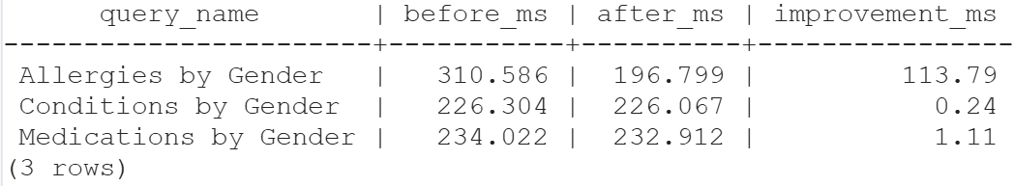
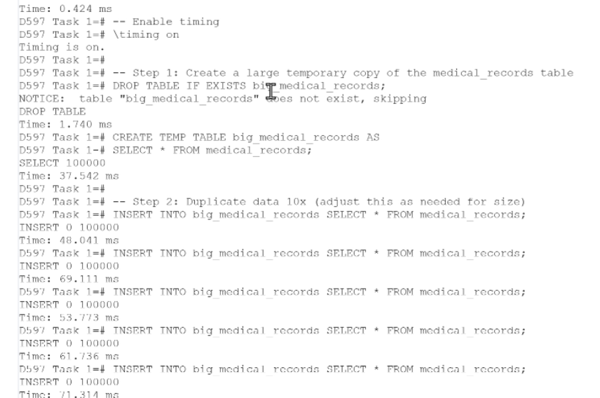
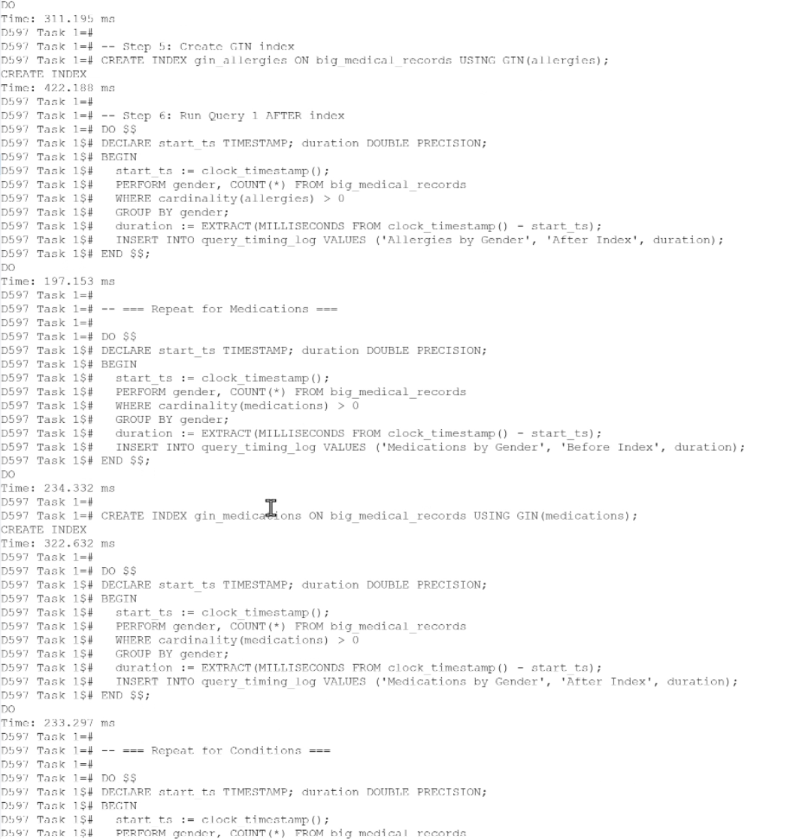
I created a Generalized Inverted Index (GIN) and duplicating the data tenfold. The GIN index significantly improved the performance of text search queries by allowing faster search operations on columns with extensive text data. Additionally, duplicating the data helped test the scalability and efficiency of the optimizations under a larger dataset. This will allow visible improvement times in running the queries.
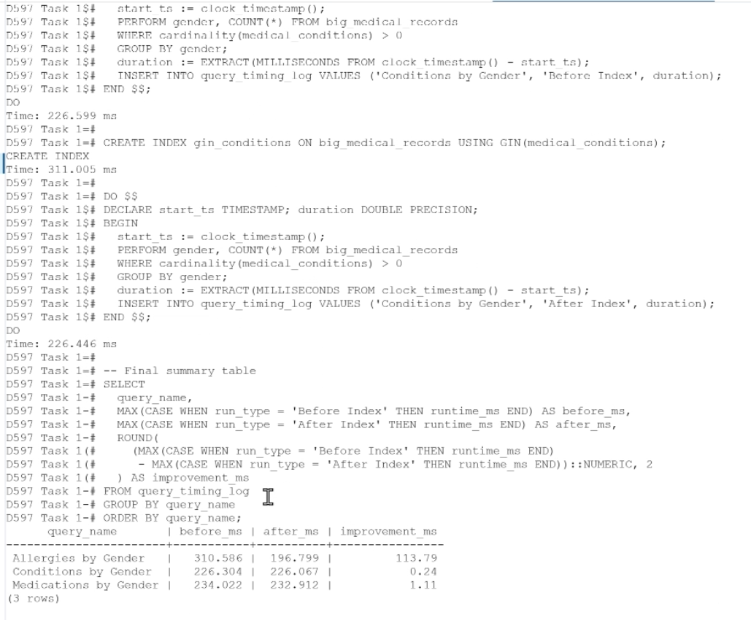
There were no sources used.

